***This summer go GREEN with CIU!***



**ECO TEENS Summer Academy 2020**

* LEARN ABOUT SUSTAINABLE BUSINESS&ENERGY
* EXPLORE OUR SUSTAINABLE FARM&GARDERN
* JOIN US IN SUSTAINABLE MANUFACTURING
* VISIT TASHKENT NATURE PARK
* CREATE IN PROJECT DAYS
* RECYCLE &UPCYCLE WITH US...

**2 WEEKS 350 EUROS ALL- INCLUSIVE\***

Tailored for students of all ages, adults and professionals looking for a sustainability course.

**▌Dates:** 29/06/2020-30/08/2020

**▌Intakes:** Every Sunday

**▌Place:** Nicosia, North Cyprus

**▌Age:** 12 years old and above

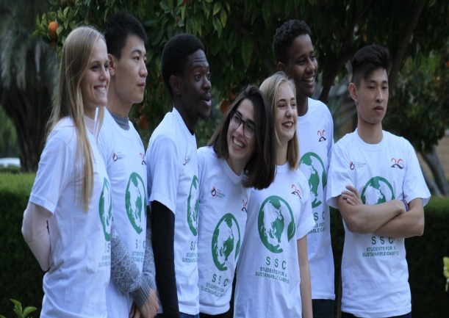 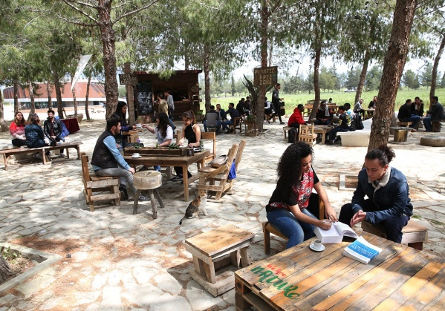

Last intake 17/08/2020

*some off-campus activities will be charged extra (e.g. bowling, cinema, boat tour etc.)

**Sample two weeks program**

|  |  |  |  |  |  |  |  |  |  |  |  |  |  |  |  |  |  |  |
| --- | --- | --- | --- | --- | --- | --- | --- | --- | --- | --- | --- | --- | --- | --- | --- | --- | --- | --- |
|  | **08:00-08:45** | **08:45-09:00** | **09:00-**  **09:40** | **09:40-**  **09:50** | **09:50-**  **10:30** | **10:30-**  **10:40** | **10:40-**  **11:20** | **11:20-**  **11:30** | **11:30-**  **12:10** | **12:10-**  **12:20** | **12:20-**  **13:00** | **13:00-**  **14:00** | **14:00-14:50** | **15:00-**  **15:50** | **15:50-**  **18:00** | **18:00-**  **19:00** | **19:00-20:00** | **20:00-22:00** |
| **Monday** | **Breakfast** | | **Registration** | | **INTRODUCTION TO SUSTAINABILITY** | | | | | | | **Lunch** | **Afternoon Workshop** | **Campus and Lefkosa Tour** | | | **Dinner on Campus** | **Welcome Party** |
| **Tuesday** | **Breakfast** | **Group Meeting** | **SUSTAINABLE GARDENING** | | | | | | | | | **Lunch** | **Afternoon Workshop** | **Girne Beach** | | | **Dinner on Campus** | **Open Air Cinema** |
| **Wednesday** | **Breakfast** | **Group Meeting** | **SUSTAINABLE MANUFACTURING** | | | | | | | | | **Lunch** | **Afternoon Workshop** | **CIU Arena Sport Activities** | | | **Dinner on Campus** | **Karaoke Night** |
| **Thursday** | **Breakfast** | **Group Meeting** | **SUSTAINABLE FARMING** | | | | | | | | | **Lunch** | **Afternoon Workshop** | **Famagusta Tour** | | | **Dinner on Campus** | **Go Karting** |
| **Friday** | **Breakfast** | **Group Meeting** | **PROJECT DAY** | | | | | | | | | **Lunch** | **Afternoon Workshop** | **Girne Tour** | | | **Dinner on Campus** | **Disco** |
| **Saturday** | **Breakfast** | **Group Meeting** | **Golden Beach Karpaz Trip** | | | | | | | | | | | | | | **Dinner on Campus** | **Free Time** |
| **Sunday** | **Breakfast** | **Group Meeting** | **Iskele Beach Trip** | | | | | | | | | | | | | | **Dinner on Campus** | **Bowling Night** |
| **Monday** | **Breakfast** | **Group Meeting** | **SUSTAINABLE ENERGY** | | | | | | | | | **Lunch** | **Afternoon Workshop** | **CIU Arena Sport Activities** | | | **Dinner on Campus** | **Karaoke Night** |
| **Tuesday** | **Breakfast** | **Group Meeting** | **SUSTAINABLE ECONOMY** | | | | | | | | | **Lunch** | **Afternoon Workshop** | **Guzelyurt Tour** | | | **Dinner on Campus** | **Open Air Cinema** |
| **Wednesday** | **Breakfast** | **Group Meeting** | **VISIT TO NATURE PARK** | | | | | | | | | **Lunch** | **Afternoon Workshop** | **Beach** | | | **Dinner on Campus** | **Go Karting** |
| **Thursday** | **Breakfast** | **Group Meeting** | **RECYCLING&UPCYCLING** | | | | | | | | | **Lunch** | **Afternoon Workshop** | **Blue Mansion Tour** | | | **Dinner on Campus** | **Salsa Night** |
| **Friday** | **Breakfast** | **Group Meeting** | **PROJECT DAY** | | | | | | | | | **Lunch** | **Afternoon Workshop** | **English Test** | | | **Dinner on Campus** | **Concert** |
| **Saturday** | **Breakfast** | **Group Meeting** | **Golden Beach Karpaz Trip** | | | | | | | | | | | | | **Goodbye Party (Certificates, Dinner)** | | |
| **Sunday** | **Breakfast** | **Group Meeting** | **Departure Day and on-campus activities** | | | | | | | | | | | | | | | |

Regular fee of 350 Euros includes tuition, accommodation in a double room, meal plan, internet access, excursions, entertainment program on

campus*, CIU Arena access, transfers and VAT.

A refundable accommodation deposit of 150 Euros must be paid in cash upon arrival.

*Some off-campus ctivities will be charged extra (e.g. bowling, cinema, boat tour etc.)

Airplane ticket and health insurance is not included.

[**www.ciu.edu.tr**](http://www.ciu.edu.tr/)

[**cis@ciu.edu.tr**](mailto:cis@ciu.edu.tr)

Each additional week is 100 Euro.